How to use server:

Startup:

Required input - IP for server and port number



User will be promoted whether to initialize the trie tree with a saved word list from previous execution. (file is triesave.txt)  


User can also initialize with their own word list from a file



The user provide file format is as such:  
<word>

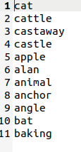

Server will be stopped by hitting CTL+Z which will ask the user if they wish to save the current trie tree (triesave.txt)



Trie tree will be saved in format as such:

<word> <popularity>



How to use client

Client requires user provide IP and Port of the server



Client will check if ip and port is valid then establish initial connectivity check:

Once passed the client will show the menu  
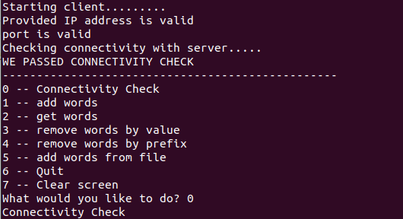

User can conduct a connectivity check at any time.

Once action is processed. The client will exit